# **Take and Make: Experimental Mathematics Cucumber Edition**

Lauren Siegel

April 10, 2020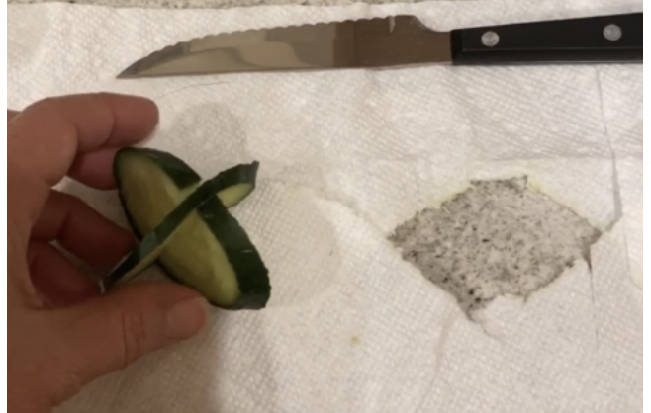

Here’s a fun one! Inspired by a conversation with Chris Daniels of Public Math.

He said roll paper around a cylinder and cut on an angle to get an ellipse and produce a sine wave. So we did! And you can too. Then you can make a roller from ellipses, reflect your sine curve and roll the elliptical roller along the sine curve track.

If your program is not vegetable friendly and you’d like something more durable, you can make a wooden track and ellipse using our files.

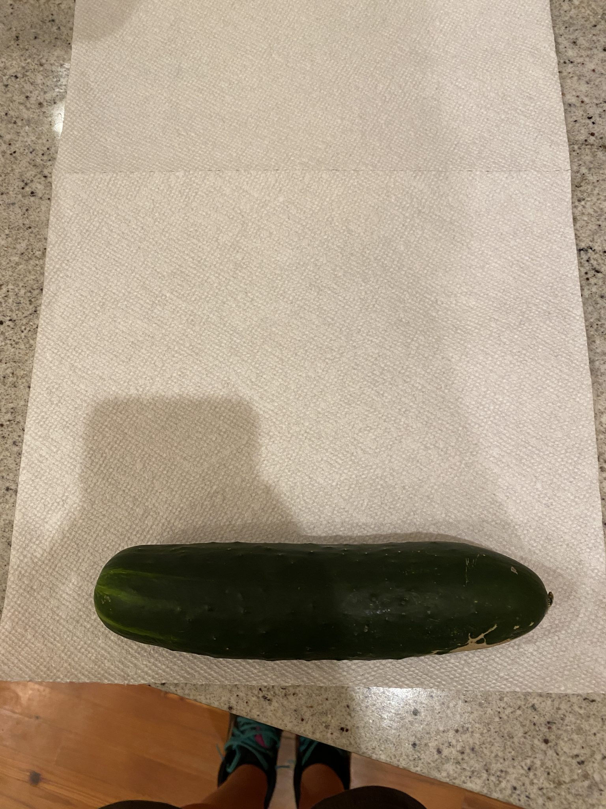

CUCUMBER, PAPER TOWEL

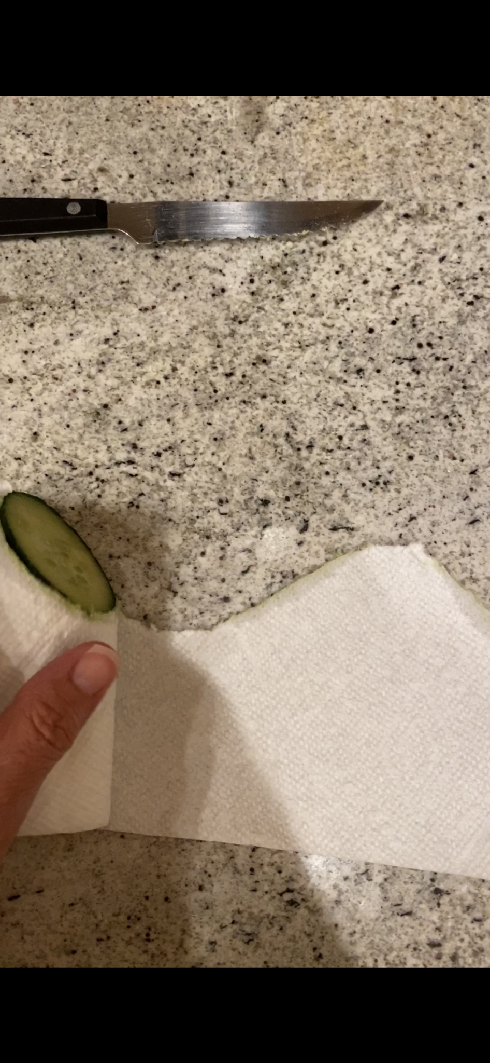

ROLL UP CUCUMBER IN TOWEL AND CUT ON ANGLE

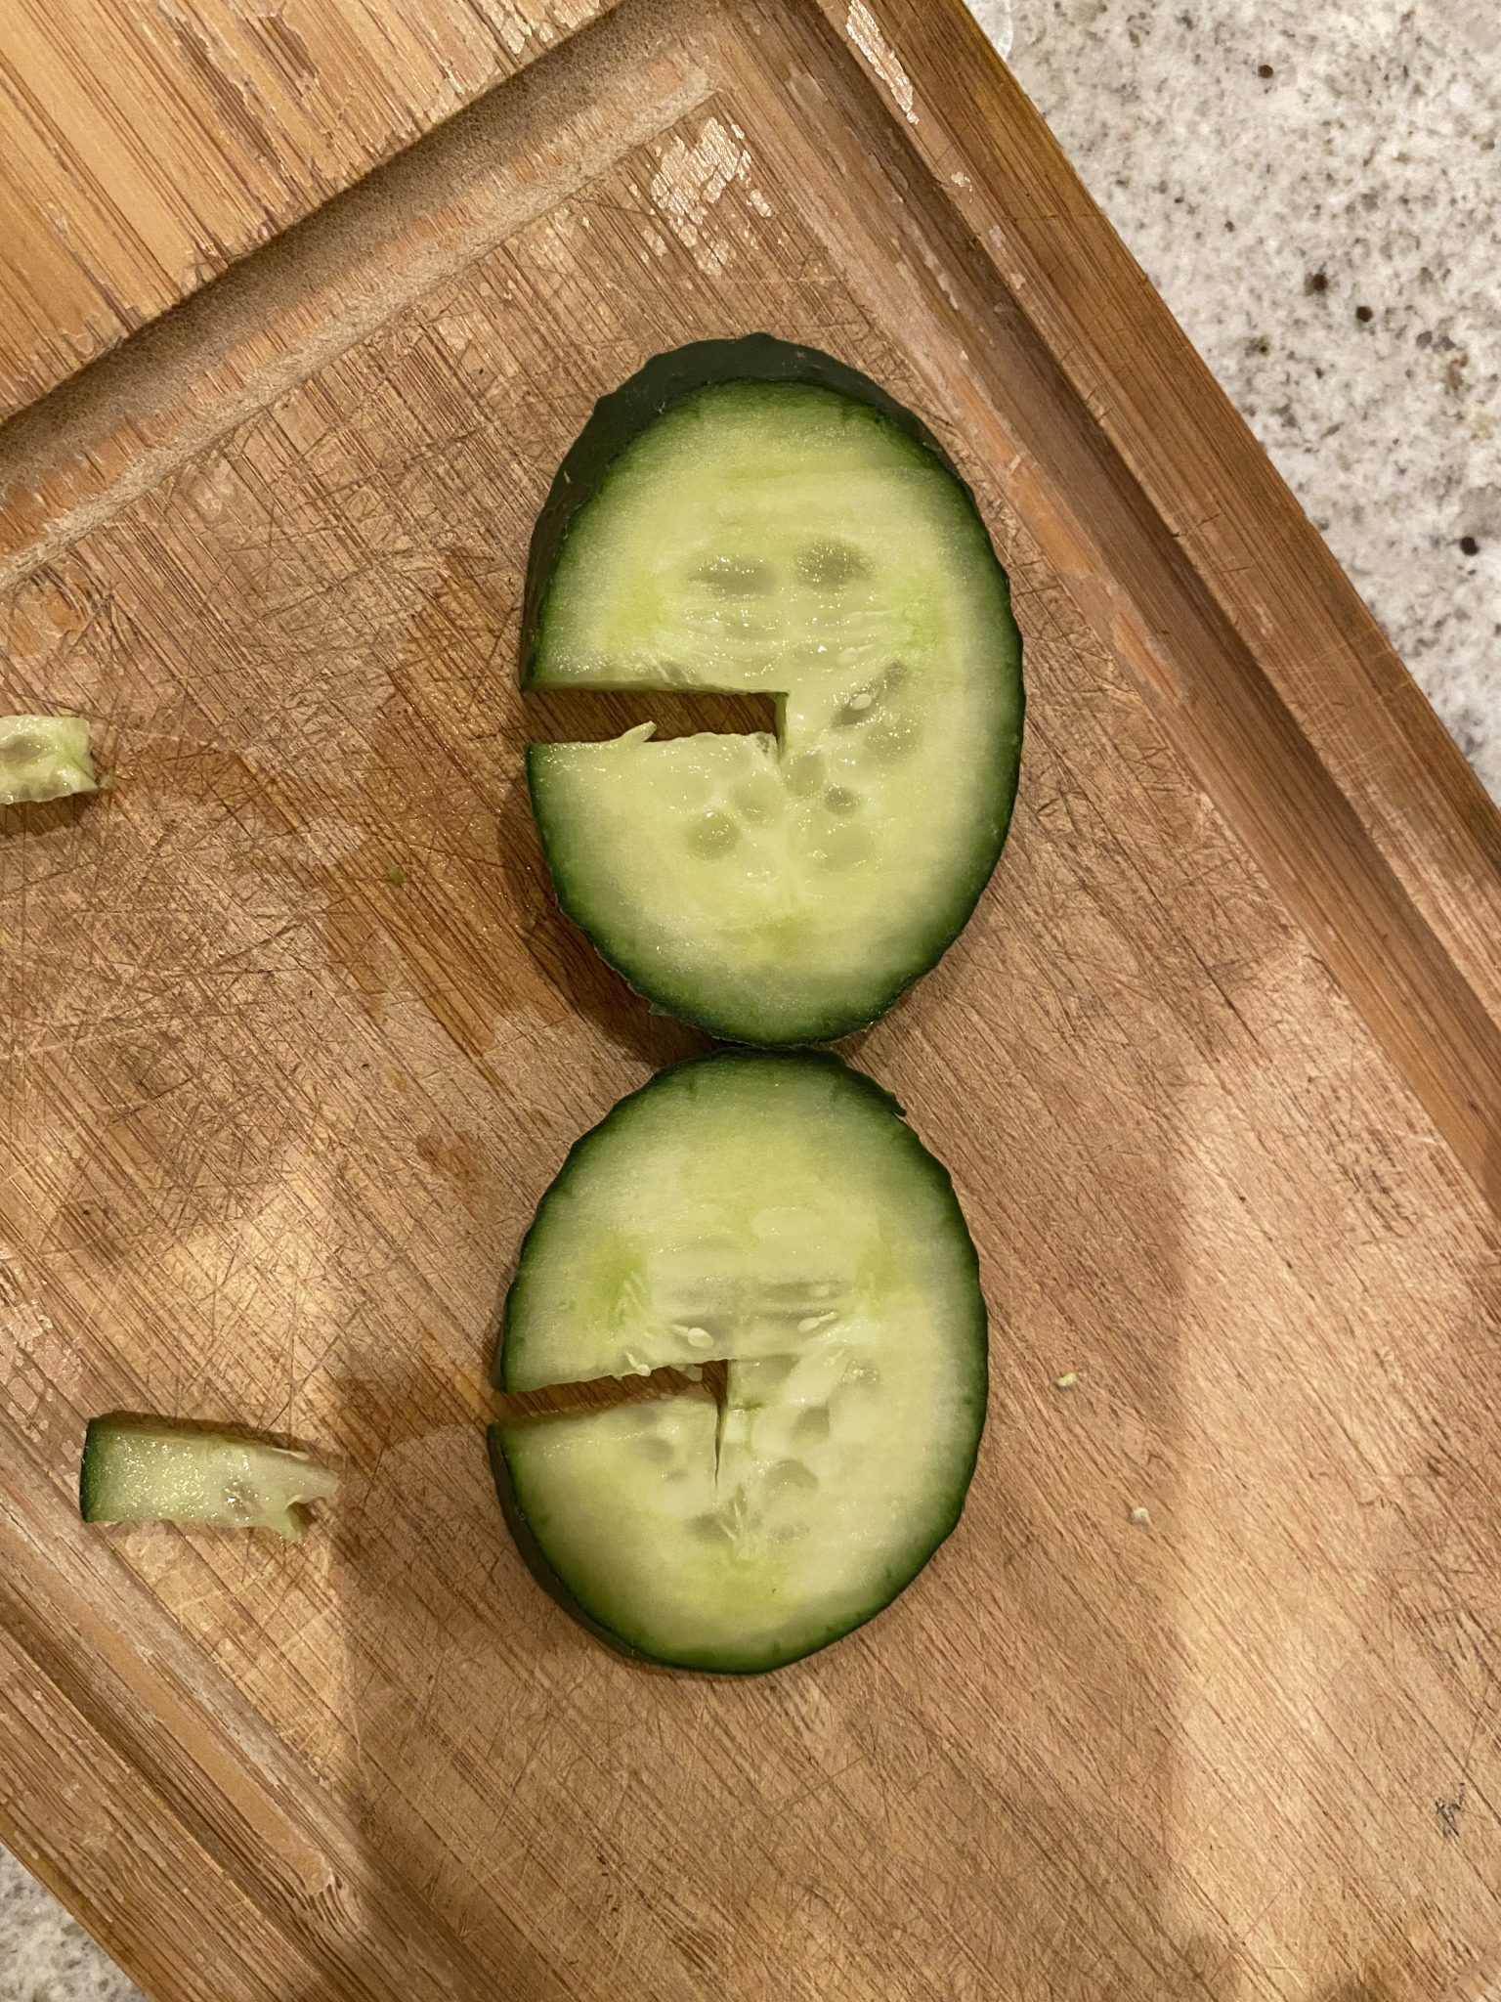

CUT TWO ELLIPSES WITH NOTCHES TO ASSEMBLE ROLLER

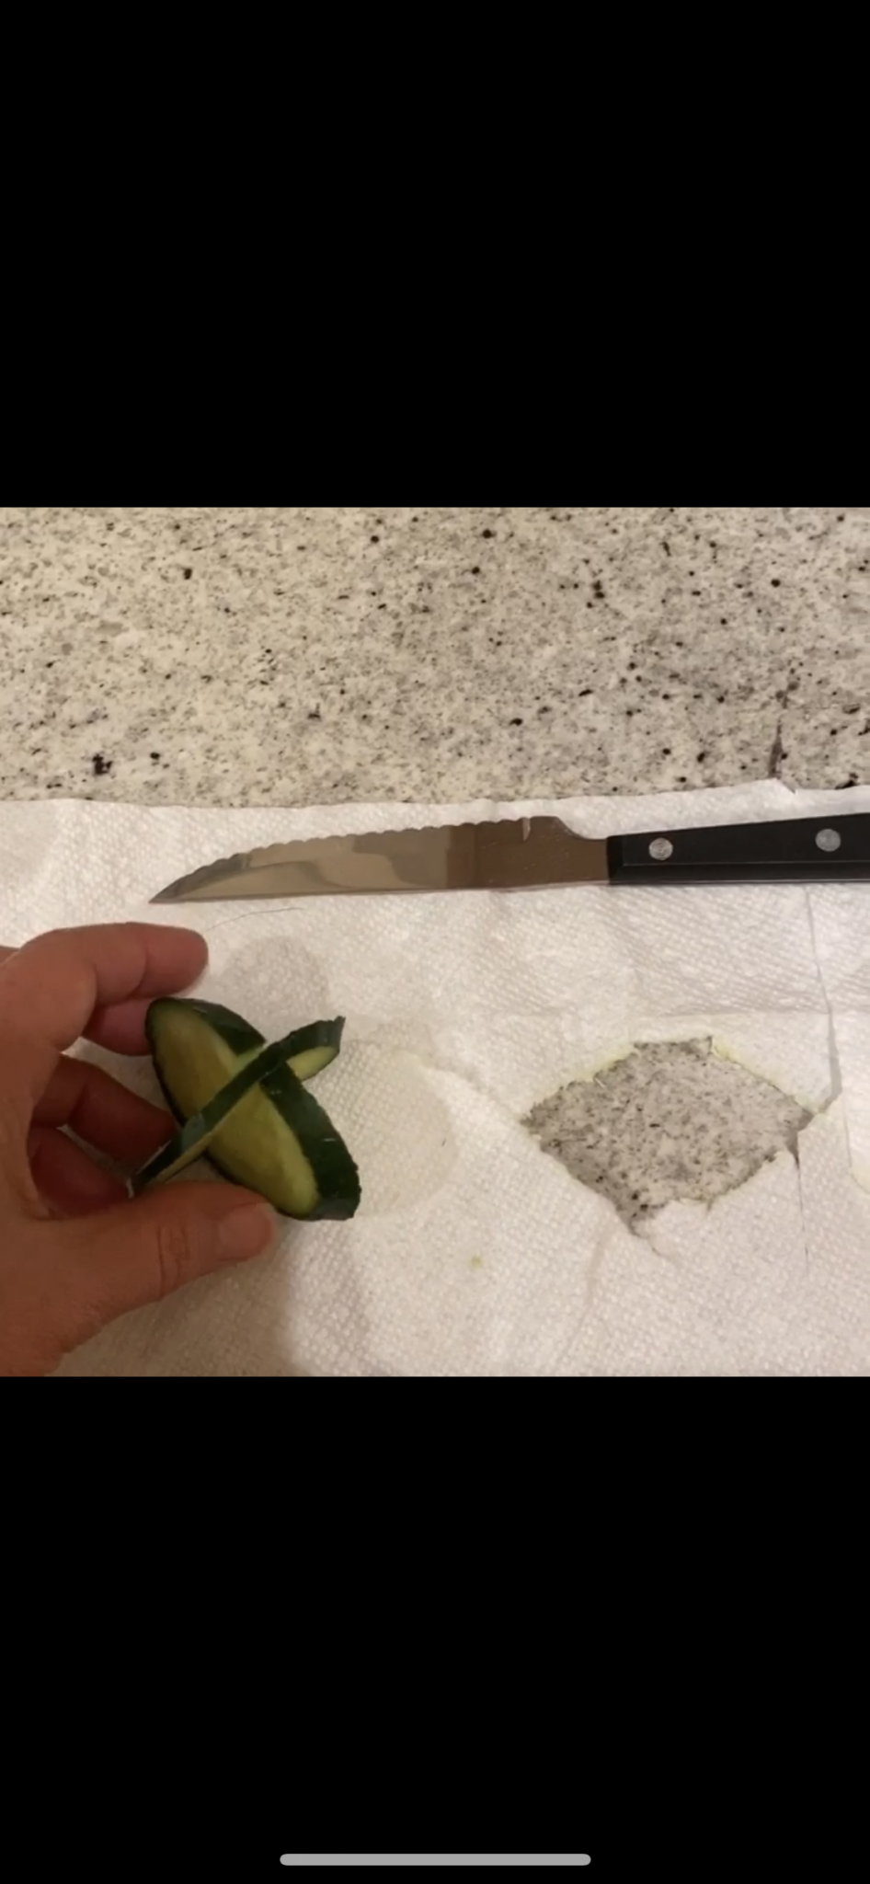

UNROLL SINE CURVES, ARRANGE AS A REFLECTION AND ROLL YOUR ROLLER!

